Appendix C: IEEE 830 Template
Software Requirements Specification
for
«Medical Clinic System for Students»

Version «1.0.3»
Prepared by «Anas Abdellatif»
«LODZ UNIVERSITY OF TECHNOLOGY - IFE»
«14.04.2026»
«Page Break»
Table of Contents
«Table of Contents»
Revision History
Name | Date | Reason for Changes | Version
«Anas Abdellatif» | «10.3.2026» | «Initial Version» | «1.0.0»
Anas Abdellatif | 29.04.2026 | Added Use Case UML Diagram [Sec 3.0], Hardware Interfaces [Sec 4.2] and Administrator user class | 1.0.1
Anas Abdellatif | 6.05.2026 | Added Class Diagram | 1.0.2
Anas Abdellatif | 18.05.2026 | Added State Diagram. | 1.0.3
«Page break»
1. Introduction
1.1. Purpose
The purpose of this document is to specify the software requirements for the University Medical Clinic Appointment System, Version 1.0.3. This Software Requirements Specification provides a comprehensive description of the system's core capabilities. It covers the entire scope of the initial product, which includes patient authentication, real-time doctor and service availability tracking, scheduling limit enforcement, and automated check-in management.
1.2. Document Conventions
This document adheres to the IEEE Std 830 guidelines for Software Requirements Specifications. Every functional and non-functional requirement is assigned a unique identifier (e.g., REQ-1.1, NF-1.1) to ensure full traceability. It is assumed that every requirement statement possesses its own priority and operates as an independent, testable unit.
1.3. Intended Audience and Reading Suggestions
This document is intended for a diverse audience involved in the lifecycle of the University Medical Clinic Appointment System. The primary readers and suggested reading sequences are as follows:
- Project Managers and Stakeholders: Should review Section 1 (Introduction) and Section 2 (Overall Description) to gain a comprehensive understanding of the product scope, healthcare objectives, and system context.
- Software Developers and Architects: Should focus heavily on Section 4 (External Interface Requirements), Section 5 (System Features/Modules), and Section 6 (Nonfunctional Requirements) for detailed technical specifications required for system implementation.
- Quality Assurance (QA) and Testing Teams: Should utilize Section 5 and Section 6 as the definitive source for developing test plans, test cases, and validation procedures based on the specified functional and non-functional criteria.
1.4. Product Scope
The University Medical Clinic Appointment System is a centralized web application designed to manage the scheduling of medical consultations and health services for university students. Currently, reliance on walk-in queues and phone-based booking is causing significant frustration and extended wait times for students requiring medical care.
The primary objective of this system is to optimize healthcare delivery by providing a transparent, automated booking workflow. Key benefits include real-time availability tracking of clinic staff, prevention of double-booking, and automated appointment status updates based on patient check-in data. By ensuring organized access to medical care and eliminating scheduling conflicts, the software directly aligns with the university's goal of providing a highly efficient and supportive student health infrastructure.
1.5. References
• Juwaied, A. (PhD.). "Software Engineering LAB 1: REQUIREMENTS ANALYSIS". Lodz University of Technology - IFE.
• IEEE Computer Society. "IEEE Recommended Practice for Software Requirements Specifications" (IEEE Std 830-1998).
Description
2.1. Product Perspective
The University Medical Clinic Appointment System is a new, self-contained software solution designed to manage the scheduling and patient flow within the campus student health center.
Unlike general campus scheduling tools, this system focuses on medical confidentiality and time-sensitive appointments. Currently, students and staff struggle with long waiting room times and disorganized appointment management. The proposed system provides a centralized platform allowing students to view available medical staff or services via a mobile-friendly interface and reserve them for specific time slots. It manages physician availability, synchronization with on-site check-in kiosks, and administrative control over the daily clinic schedule.
2.2. Product Features
- Viewing available doctors and medical services on campus.
- Displaying the availability schedule for each medical professional.
- Booking a medical appointment for a selected time slot.
- Viewing and managing personal patient reservations.
- Canceling existing appointments.
2.3. User Classes and Characteristics
Students (Patients) represent the primary user group of the system. They will use the system to find available doctors and make appointments for medical care. Characteristics:
- Basic technical knowledge.
- Occasional to frequent system usage depending on health needs.
- Access primarily through mobile devices or laptops.
Medical Staff and Administrators represent the secondary user group of the system. They will use the system to manage the clinic schedule, monitor patient appointments, and oversee daily triage operations. Characteristics:
- Continuous system usage during administrative working hours.
- System usage focused on daily schedule management and patient intake.
2.4. Operating Environment
The system shall operate in the following environment:
- Web application accessible through all modern browsers, fully responsive for mobile and desktop.
- The system will be hosted on a secure university server or compliant cloud infrastructure to meet medical data privacy standards.
2.5. Design and Implementation Constraints
«
The development of the system may be limited by the following constraints:
- The system must operate through standard web browsers.
- Access to the system requires valid university authentication credentials.
- The system must support multiple concurrent users during peak academic hours.
- The system must strictly adhere to university data privacy and medical confidentiality policies.
2.6. User Documentation
The following documentation will be provided to support system users:
- A user guide explaining how to book and manage medical appointments.
- An administrator manual describing how to manage clinic schedules and verify check-ins.
- Online help documentation available within the application.
- Documentation will be delivered in digital format as a web sub-page.
2.7. Assumptions and Dependencies
The system requirements are based on the following assumptions:
- Users have valid university accounts for authentication.
- Medical staff schedules are accurately entered into the system.
- The university provides secure server infrastructure or hosting for the system.
- Users have internet access to interact with the application.
3. System Features
3.0. «Use Case Model»
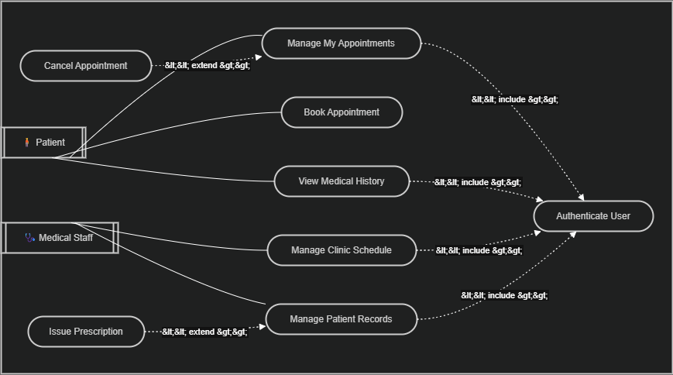
3.1. «Provider Browsing»
The system shall allow users to view available doctors and medical services at the university clinic. Users shall be able to check provider availability for specific dates and time slots before booking an appointment.
3.2. «Appointment Booking»
The system shall allow users to schedule an appointment for a selected time period. The reservation feature ensures that a doctor's time slot cannot be double-booked by multiple patients.
3.3. «Patient Appointment Management»
The system shall allow users to view and manage their upcoming medical appointments. Users shall be able to cancel reservations or review previously attended visits.
3.4. «Clinic Administration»
The system shall allow clinic administrators and medical staff to manage schedules and appointments. Administrators shall be able to add new available slots, block out unavailable times, and monitor the daily patient queue.
4. External Interface Requirements
4.1. User Interfaces Overview
The system shall provide a graphical user interface (GUI) accessible through a web browser. The interface will allow users to interact with the system through standard graphical elements such as buttons, menus, forms, and calendar views.
Users shall interact with the system through the following screens:
- Login Screen: Users enter their university credentials to access the system.
- Service List Screen: Displays available medical services (e.g., General Practice, Counseling, Vaccinations).
- Availability Schedule Screen: Shows available time slots for each service/doctor using a calendar-style interface.
- Booking Screen: Allows the user to select a time slot, provide a brief (optional) reason for the visit, and confirm the appointment.
- My Appointments Screen: Displays the list of upcoming and past appointments made by the user.
- Administration Panel: Available only to medical staff for managing schedules, viewing patient lists, and processing check-ins.
Users shall interact with the interface using common actions such as clicking buttons, selecting time slots, entering information into forms, and navigating menus. The interface shall provide immediate feedback, including:
- Confirmation messages after successful bookings.
- Error messages when a selected time slot is already taken.
- Notifications when an appointment is canceled.
Minimum interface requirements include consistent screen layouts, clearly labeled navigation, visible error messages, and a responsive design for mobile and desktop compatibility.
4.2. Hardware Interfaces
The System shall interface with the hardware infrastructure located at the physical clinic. The system acts as a management layer that processes data from check-in stations and pushes queue updates to waiting room displays.
Check-in Data Integration The system shall ingest real-time data from the clinic's patient check-in kiosks or receptionist terminals.
- The system shall monitor the "Checked-In" status sent by the terminal.
- This data shall be used for schedule management: if a patient does not check in within 15 minutes of their appointment start time, the system may flag the appointment as a "No-Show" for administrators to review.
External Status Displays The system shall serve as the data provider for the electronic queue display panels mounted in the clinic waiting room.
- Data Push: The system shall update the display's API every time a patient is called or checked in.
- Visual Output: The system shall provide the display with anonymized queue numbers (e.g., "Ticket A42 - Proceed to Room 3") to maintain patient privacy.
4.3. Software Interfaces
The University Medical Clinic Appointment System shall interact with several external software components that support authentication, data storage, and system communication.

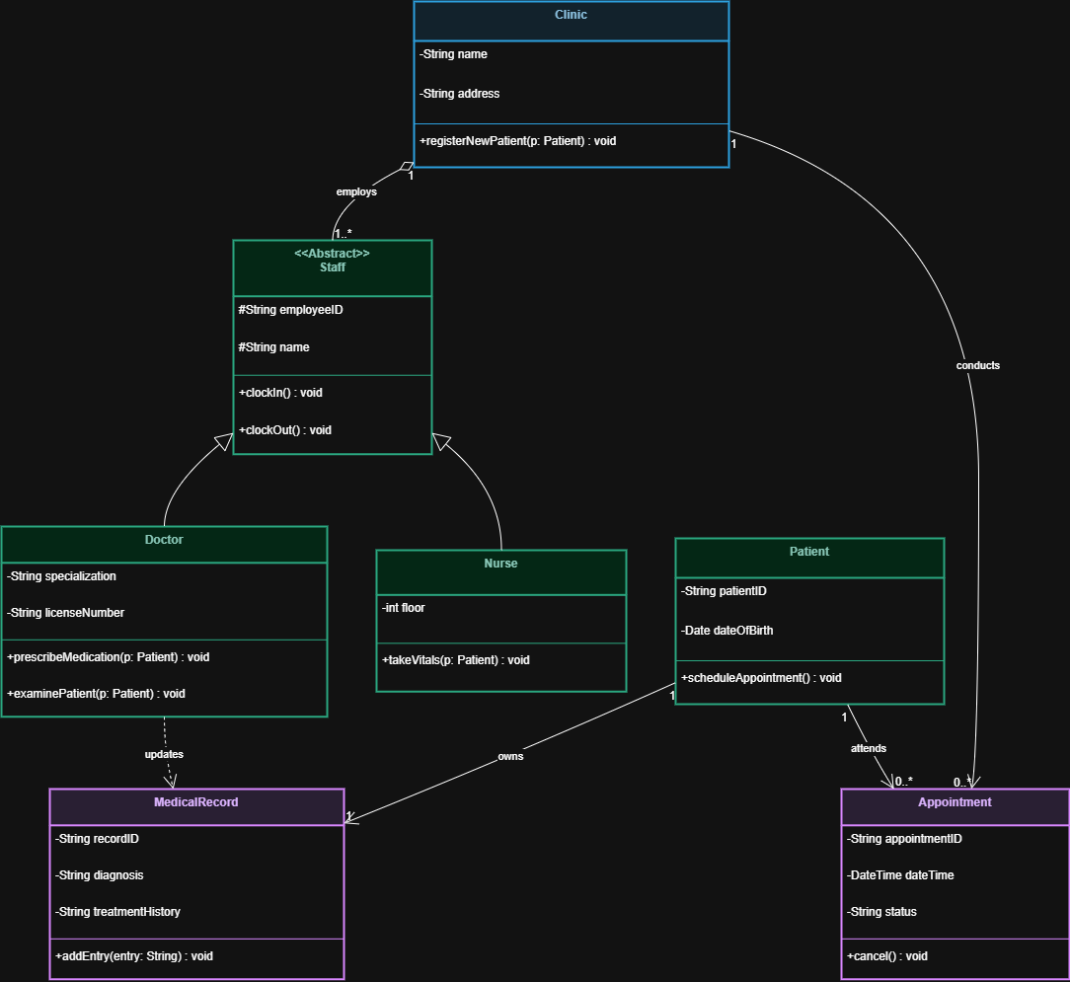

University Authentication Service
- The system shall interface with the university authentication service (SSO) to verify user identities during login.
- The system shall receive the user identifier (Student ID), authentication status, and user role (Patient vs. Staff).
- For privacy compliance, the scheduling module shall decouple the student's medical appointment data from their primary academic records.

Database Management System
The system shall interface with a secure database used to store appointment-related data. The database shall store only operational information required for system functionality, including:
- Appointment identifier
- Doctor/Service identifier
- Appointment start and end time
- User identifier (Student ID) associated with the appointment
- Appointment status (Scheduled, Checked-In, Completed, Canceled, No-Show)
The application shall communicate with the database using secure, encrypted queries.
5. System Features/Modules
5.1. « Schedule Status Check »
Description and Priority: This feature allows students to view the availability of doctors and medical services before scheduling an appointment. Users can check which times are free. Priority: High.
Stimulus/Response Sequences:
- Stimulus: The user requests the list of available medical services.
- Response: The system displays the services and available doctors.
- Stimulus: The user selects a specific doctor or service.
- Response: The system displays the available booking schedule for the selection.
Functional Requirements:
- REQ-1.1: Upon a user request, the system shall display a list of all available clinic services and doctors.
- REQ-1.2: Upon selecting a service, the system shall display the open appointment schedule for that specific service.
- REQ-1.3: The system shall visually distinguish between available, booked, and blocked time slots.
- REQ-1.4: The system shall immediately update schedule availability information after any booking or cancellation occurs.
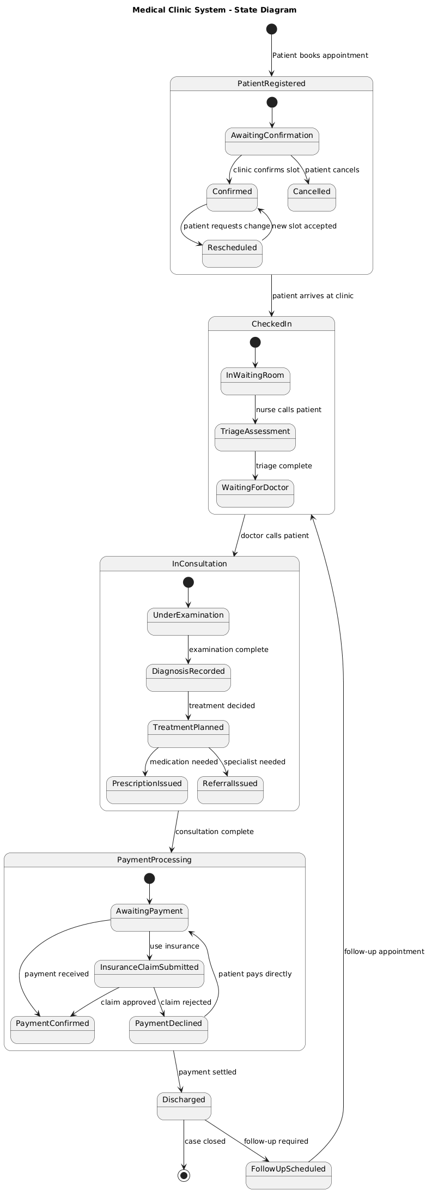
5.2. «Appointment Booking»
Description and Priority: This feature allows users to reserve a medical consultation for a selected time slot. The system ensures strict schedule enforcement so doctors are not double-booked. Priority: High.
Stimulus/Response Sequences:
- Stimulus: The user selects an available time slot and confirms the booking.
- Response: The system creates the appointment and provides a confirmation (with a booking reference/QR code for check-in).
- Stimulus: The user attempts to select a time slot that was just booked by someone else.
- Response: The system displays an error message indicating the slot is no longer available and refreshes the calendar.
- Stimulus: The user requests to view their upcoming appointments.
- Response: The system retrieves and displays the active appointments linked to the user's ID.
- Stimulus: The user cancels an appointment.
- Response: The system removes the appointment, updates the doctor's calendar to "Available", and logs the cancellation.
Functional Requirements:
- REQ-2.1: Upon an appointment request, the system shall verify in real-time whether the selected doctor and time slot are still available.
- REQ-2.2: If the selected time slot is available, the system shall create an appointment record.
- REQ-2.3: The system shall assign a unique appointment reference number or check-in code to each booking.
- REQ-2.4: If the selected time slot is already reserved, the system shall reject the request and prompt the user to select another time.
- REQ-2.5: Upon user request, the system shall display all upcoming and past appointments associated with their user identifier.
- REQ-2.6: Upon a cancellation request by the user, the system shall update the corresponding appointment record to 'Canceled'.
- REQ-2.7: After an appointment is canceled, the system shall immediately release the time slot back into the available pool.

6. Nonfunctional Requirements
6.1. Performance
- NF-1.1: The system shall respond to user interface navigation requests within 2 seconds under normal operating conditions.
- NF-1.2: The system shall support at least 5000 concurrent user sessions without performance degradation during peak campus hours.
- NF-1.3: The system shall update the doctor's calendar availability across all client screens within 5 seconds after an appointment is booked or canceled.
- NF-1.4: The system shall process and finalize booking database transactions within 3 seconds of the user clicking confirm.
6.2. Security
- NF-2.1: The system shall authenticate all users utilizing the secure university Single Sign-On (SSO) service before allowing access to the scheduling portal.
- NF-2.2: The system shall maintain strict data segregation; it shall store only the necessary scheduling metadata and shall not function as a complete Electronic Health Record (EHR) system.
- NF-2.3: The system shall transmit all user requests, responses, and booking data using secure, encrypted HTTPS communication protocols.
6.3. Reliability
- NF-3.1: The system shall maintain 99.5% uptime during standard academic semesters.
- NF-3.2: The system's database architecture shall utilize transaction locks to mathematically prevent the double-booking of a single physician during overlapping time slots.
6.3. Usability
- NF-4.1: The user interface shall be intuitive enough that a first-time user can successfully book a medical appointment within 2 minutes of logging in.
- NF-4.2: The system interface shall display highly visible confirmation messages and provide digital check-in instructions immediately upon a successful booking.

